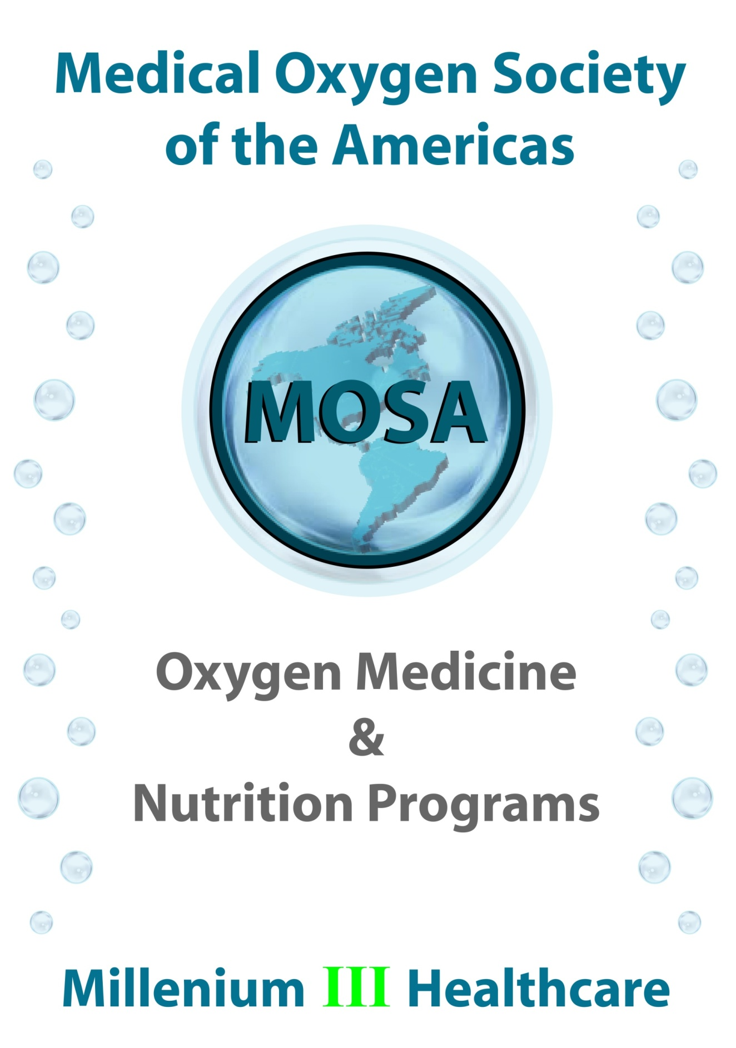

**­­­­­­­**

**Oxygen Medicine**

**In**

**Veterinary Medicine**

**- OXYGEN MEDICINE** can effectively treat a ***wide spectrum of diseases and conditions*** in innumerable animal species and breeds.

**- OXYGEN MEDICINE** will offer potent and safe ***anti-cancer, anti-viral, anti-bacterial*** and - ***anti-fungal*** properties.

**-** After treating ***sick kittens*** with **OXYGEN MEDICINE** (instead of the common antibiotics) veterinarians discovered that ***coccidiosis was treated inadvertently after only 5 days***.

**-** In another application**, OXYGEN MEDICINE** produced very good results with ***arthritic conditions*** and with ***no risk of infection***.

**-** In equine medicine studies, **OXYGEN MEDICINE** has also proved very effective in acute and ***chronic viral diseases*** of horses as a *virucidal agent* in ***reversing positive antibody tests***.

**- OXYGEN MEDICINE** will improve the general health of horses and other animals and will ***aid recuperation after illness, surgery or treatment***.

**-** A growing number of farmers are applying **(O3) OZONE OXYGEN** to their livestock, to cut losses from ***disease and infected wounds***.

**(H2O2) HYDROGEN PEROXIDE**is often added in animals' drinking water, to ***boost the immune system and reduce animal illnesses***.

**O2 Oxygen**

**(HBOT) Hyperbaric Oxygen Therapy**

**Treatments & Healing Benefits**

**Veterinary Medicine**

Hyperbaric Oxygen Therapy (HBOT), a new state-of-the-art adjunctive therapy is now available for veterinary patients at **VCA SouthPaws Veterinary Specialists & Emergency Center**.

Our HBOT team is led by Dr. Jeff Norton of our Surgery Department. Dr. Norton is a respected veterinary surgeon, researcher and speaker – and has extensive training in HBOT:

“I’ve used HBOT in hundreds of soft tissue, orthopedic and neurosurgical patients over the last four years before I joined VCA SouthPaws team, and am very excited about being able to add this therapeutic modality which will improve outcomes in patients with ***osteomyelitis, crush/   
degloving injuries, skin graphs and flaps,*** ***and IVDD***.

We’re expecting to see faster recovery times in patients who have delayed post-radiation therapy healing and in those with acute pancreatitis as well. If you think you have a patient who might benefit from HBOT, please call me.”

**HBOT effectively treats each of these conditions:**

* ***Acute ischemias, including compartment syndrome and crush injuries***
* ***Poorly healing wounds***
* ***Burns***
* ***Necrotizing soft tissue infections***
* ***Intracranial abscesses***
* ***Delayed radiation injuries***
* ***Clostridial myositis/myonecrosis***
* ***Refractory osteomyelitis***
* ***Others (carbon Monoxide poisoning, air/gas embolism)***

**Possible additional indications include:**

* ***Spinal cord injuries and nerve injuries***
* ***Peripheral neuropathies***
* ***Ileus &post-operative GI surgeries with compromised vasculature***
* ***Pancreatitis & Hepatitis***
* ***Fungal diseases***
* ***Cranial traumas***
* ***Cellulitis & diabetes complications***

[http://www.vcahospitals.com](http://www.vcahospitals.com/main/news/article/hyperbaric-oxygen-therapy-hbot-available-at-southpaws/21833)  
  
  
  
"HBOT is a proven and ***highly successful, non-invasive treatment*** method in which patients breathe pure oxygen inside a pressurized chamber. 

During treatment the blood plasma becomes saturated with oxygen which ***promotes a*** ***wide range of healing responses*** in the body.

The O2 Vet company has received media and industry coverage for successfully treating a number of high profile cases  including patient recovery from ***long-term medical issues***, ***accelerated healing*** for sports personalities***, rehabilitating*** a wild albatross with a ***broken wing***, accelerating healing for rare birds such as a Takahe and a little blue penguin."

<http://www.nzcapstrat.com/content/02-vet>

"Offering Hyperbaric Oxygen Therapy to is providing a valuable service that will often ***prolong or extend the animal’s life***, or ***speed healing*** of many non-life threatening injuries and illnesses. 

HBOT can be used to ***treat injuries from surgery***, activity, car accidents, fire (***burns & lung damage***), ***broken bones, trauma, infection***, and others."

<http://www.equineox.com/hbos.html>

"When I started the human hyperbaric company, I was aware that this medical technology was not widely utilized. My motto is, 'Don't turn your back on change, because you could get run over.' ***Today, hospitals around the country are using HBOT to treat patients***."

He soon wondered why it shouldn't also be used for our best friends. After all, "animals suffer from many of the same disease states that we do ... some people experience claustrophobia in the hyperbaric oxygen chamber, but animals don't ... dogs and cats are nesting animals."

[http://www.dogster.com](http://www.dogster.com/lifestyle/hyperbaric-chamber-for-dogs-oxygen-therapy)

**O2 Oxygen**

**(HBOT) Hyperbaric Oxygen Therapy**

**Treatments & Healing Benefits**

**Thoroughbred Race Horses**

**Equine athletes** treated with hyperbaric oxygen therapy (HBOT)  
are better able to consistently ***compete at their full potential***.

Like any medical procedure results vary, however the majority of horses showed ***vast improvements*** and ***accelerated healing***  
over conventional treatment alone.

The treatments will be used on current in-training thoroughbred and standbred horses to ***enhance post-race recovery time***.

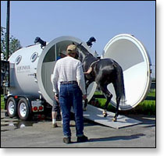

By speeding the ***healing of injury*** due to the wear and tear of racing (i.e**. *lung and micro-circulation damage***), the well-being of the horses with allow them to race more frequently, at higher levels.

***- HBOT has made possible the complete rehabilitation of horses with injuries deemed to be career ending.***

HBOT’s proven ability to accelerate healing of minor wounds has consistently returned horses back to the track, saving an otherwise failed season. ***Re-injury rates are consistently lower than without treatment.***

HBOT sessions used for general preventative athletic therapy and to treat ***minor chronic disease and infection*** allow some competition horses to race with greater frequency. Horses who could previously compete only every 2-4 weeks have been able to step to the gate weekly and *compete at their full potential*.

***- The stable with access to a hyperbaric oxygen therapy chamber has an indispensable tool to sharpen their winning edge.***

Show and race animals undergo a tremendous amount of stress from racing and travel, and  
HBOT is proving to be very instrumental in ***post-race recovery*** in the equine world. Breeders and racers may want to consider HBOT to give their animals that ***competitive edge***, so their animals are ***always at peak condition***.

**- HBOT is not only for medical treatment, but shows dramatic results in general wellness, and improved fertility.**

<http://www.equineox.com/hbos.html>

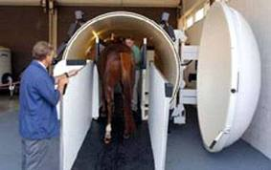

In New Horse Therapy available at **University Of Tennessee Equine Sports Medicine** has entered into a new era at the University of Tennessee College of Veterinary Medicine.

The college is now one of six veterinary facilities in the nation with hyperbaric oxygen therapy capabilities. HBOT is a therapeutic procedure designed to ***deliver increased concentrations of oxygen*** to the blood stream or directly to diseased or injured tissues.

HBOT is gaining acceptance in the medical and veterinary communities as an adjunct therapy that complements traditional ***treatment of a variety of acute and chronic conditions***.

In ***diseased or injured tissue***, the blood supply is often compromised, and the amount of oxygen delivered is reduced, which inhibits healing. This is especially true ***for injuries*** to the ***limbs of large animals*** like horses, where the blood supply is poor even in a healthy animal.

With HBOT, the patient is placed in a chamber that delivers pure oxygen under pressure, increasing the concentration of dissolved oxygen in the blood by a factor of 15 times, depending on the pressure. ***By reducing tissue swelling and inflammation***, HBOT ***enhances the repair of connective tissue*** and is beneficial in many training and ***athletic injuries***.

***Acute conditions*** that benefit from HBOT treatment include ***trauma, leg wounds, central nervous system damage*** and ***surgical trauma (incisions).***

***Chronic conditions*** improved by HBOT treatment include ***large, poorly healing wounds; bone infections; internal abscesses***; loss of blood supply and ***necrosis; foal infections*** and possibly ***laminitis***.  
  
[http://www.midsouthhorsereview.com](http://www.midsouthhorsereview.com/news.php?id=2675)

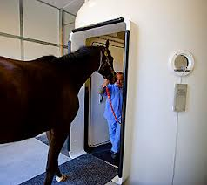

In 2000, the **Alamo Pintado Equine Medical Center** acquired the first hyperbaric oxygen chamber designed specifically for horses, and became the first veterinary hospital in the United States to offer hyperbaric oxygen therapy to equine patients.

In the past decade, the Center has incorporated new technological advances and the hyperbaric chamber now is able to immerse the patient in a pure oxygen environment at 2 to 3 atmospheres of pressure for the duration of the treatment.

This promotes an increase in tissue oxygenation by as much as 15 times over normal levels.

Some of the beneficial effects of hyperbaric oxygen therapy include increased antibacterial activities of oxygen on specific anaerobic bacteria, ***enhanced white blood cell activity, reduction of tissue edema, maintenance of tissue oxygenation*** in instances of decreased hemoglobin content in the blood, and stimulation of fibroblast activity and collagen deposition.

Collectively, these effects ***facilitate wound healing*** and ***stimulate the growth*** of capillary beds into ***injured tissues***.

[http://www.alamopintado.com](http://www.alamopintado.com/biological-medicine/hyperbaric-oxygen/)

**O2 Oxygen**

**(HBOT) Hyperbaric Oxygen Therapy**

**Treatments & Healing Benefits**

**Pets – Dogs & Puppies**

Hyperbaric Oxygen Therapy (HBOT) is a medical treatment  
offered in our Fort Pierce, FL veterinarian office that ***aids healing*** by ***reducing swelling***, controlling ***infection*** and stimulating new blood vessel formation in healing tissues.

The patient is placed in a large, clear plastic chamber that has a pressurized flow of pure oxygen about 1.5 to 3 times that of atmospheric oxygen. This allows more oxygen into the bloodstream, speeding up the healing process.

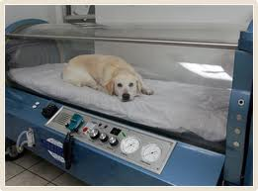

Inside the chamber, pets lie on a soft blanket and rest or sleep while the oxygen goes to work on ***wounds***, swelling, burns and other injuries or illnesses. The ***pets are comfortable and relaxed*** during dog/cat hyperbaric therapy treatment.

The total HBOT treatment time is from 1 to 2 hours, and is usually repeated twice a day.

Treatments continue until the ***doctors see a marked improvement***. When your pet is beginning to use the affected limb, or is gaining strength and function, the animal hyperbaric oxygen chamber treatments are discontinued.

Our **Fort Pierce, FL veterinarian**-administered HBOT treatment used successfully to treat:

* **Post operative swelling**
* **Snake bites**
* **Serious wounds and burns**
* **Head or spinal trauma**
* **Near-drowning or asphyxiation**
* **Smoke inhalation**

Over the past few years it has been very rewarding for the doctors and staff to observe the clinical improvement of the many cases treated by cat/dog hyperbaric oxygen therapy at our Fort Pierce, FL veterinarian hospital. The addition of this HBOT therapy has resulted in an ***obvious enhancement*** of our ability to successfully ***treat many critically-ill patients***.

<http://animalemergency.net/hbot.php>

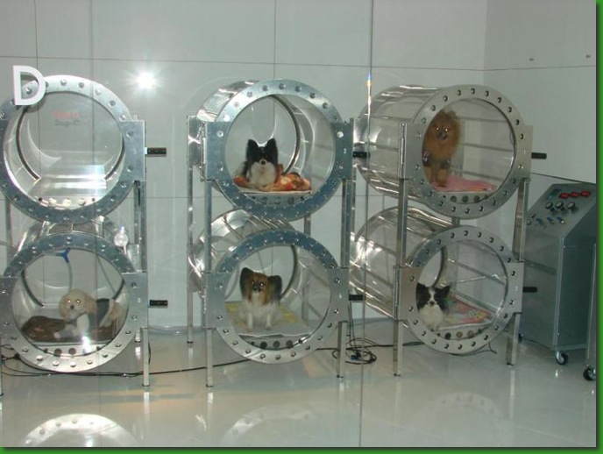

**Japanese Veterinarians** are now providing Hyperbaric Oxygen Therapy for dogs ... and is not limited by any particular disease, diagnosis, or breed.

While here in the United States, HBOT is still denied to brain-injured children and adults despite years of data accumulated since December 7, 1941 that demonstrates clear benefit and efficacy.

[http://www.hbotruth.com](http://www.hbotruth.com/files/tag-hyperbaric002c-hbo002c-veterinarian002c-dogs002c-dog0027s-life002c-brain-injury002c-brain-injured-people-.php)

**O2 Oxygen**

**(HBOT) Hyperbaric Oxygen Therapy**

**Treatments & Healing Benefits**

**Pets – Cats & Kittens**

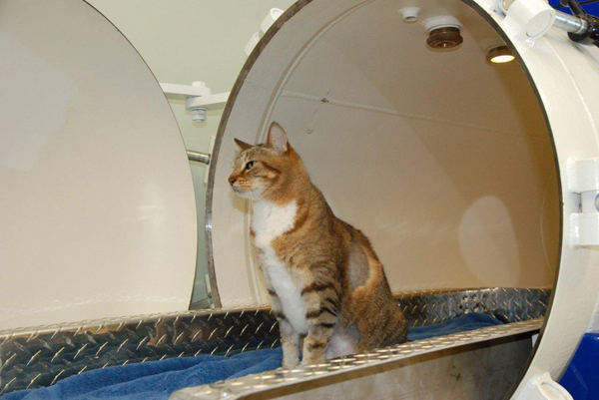

**Calusa Veterinary Center in Boca Raton, Florida**, was among the first animal hospital in the nation to acquire a hyperbaric chamber, which is more compact than ones for humans.

"Treatment times last about one hour and are given one or two times daily. Most patients require ***no sedation*** and remain calm and relaxed during the treatment." The animals safely and painlessly inhale and absorb the oxygen,” says Calusa's Dr. Andrew Turkell.  "

Hyperbaric oxygen therapy is often used in combination with other forms of therapy to treat injuries and illnesses including ***wounds*** and ***burns***, ***post-surgical swelling***, ***sepsis***, ***pancreatitis***, ***necrosis***, and ***stroke***.

It **reduces swelling and inflammation**, eases pressure and edema caused by head or ***spinal cord injuries***, stimulates new blood vessel formation in ***healing tissues***, improves control of ***infection***, and ***promotes wound healing***.

[http://www.dogster.com](http://www.dogster.com/lifestyle/hyperbaric-chamber-for-dogs-oxygen-therapy)

**O3 Ozone Therapy**

**Treatments & Healing Benefits**

**Veterinary Medicine**

In modern veterinary practice, **OXYGEN MEDICINE** has uses in treating ***acute viral infections***, ***chronic arthritic problems***, ***chronic toxic states*** and many more.

Animal studies and veterinary and equine experience, has ***consistently demonstrated*** that oxygen medicine is an ***extremely safe medicine and free from side effects*** when administered by a properly trained medical professional.

***Aging*** and ***degenerative diseases*** are caused by decreased oxygen utilization by the tissues.

Decreased oxygen utilization can be due to pre-mitochondrial factors (decreased lipolysis, inflammation, hypoglycemia, hypoxia, ischemia) or mitochondrial factors (toxicity, infections, stress, nutritional and hormonal deficiencies, decreased fitness) which causes increased free radical production and the subsequent degenerative diseases associated with aging.

**Ozone therapy** stimulates oxygen utilization by improving the NAD/NADH ratio and by decreasing the rate of decay of mitochondria present in the tissues.

**Ozone** reacts with lipids in the cell membrane to form **ozonides** which convert NADH to NAD, thus increasing oxygen utilization.

**Ozonides** are also ***antibacterial***, ***antifungal*** and ***antiviral***, and enhance chemotherapy and radiation. Cancer thrives in areas of poor oxygenation and cancers actively inhibit cellular reactions in mitochondria, creating areas of hypoxia and poor oxygen utilization.

**Ozonides** increase the function of the mitochondria increasing oxygenation of tissues, thereby ***inhibiting the spread of cancer***.

**Ozone therapy** increases the buffering of free radicals much better than oral antioxidant therapy does.

**Ozone** also stimulates cytokines (tumor necrosis factor, interleukin 2, interferon G) that fight cancer, because they stimulate the immune system without causing side effects.

**Direct ozone injection** into cancer causes tumor cell to rupture (apoptosis).

**Ozone** also protect healthy cell against the side effects of chemotherapy or radiation therapy by increasing antioxidant enzyme activity.

**1. Wound management, hot spots, abscesses, allergic dermatitis, etc.**

**2. Chronic and acute lymes disease**

**3. Acute and chronic liver disease**

**4. Acute and chronic kidney disease**

**5. Pancreatitis**

**6. Viral and bacterial diarrhea**

**7. Adjunctive cancer therapy**

**8. Stomatitis, gingivitis**

**9. Chronic ear infections, yeasty ear infections**

**10. Seizures**

**11. Autoimmune reactions**

**12. Ear hematomas**

**13. Anti-microbial - Anti-bacterial - Anti-fungal - Anti-viral**

**O3 Ozone Therapy**

**Treatments & Healing Benefits**

**Equine Medicine**

**OXYGEN MEDICINE** is very effective in acute and ***chronic viral diseases*** of horses as a virucidal agent in ***reversing positive antibody tests***, improving the general health of horses and other animals and will aid recuperation after illness, surgery or treatment.

Ozone therapy application is especially valuable in **Equine Medicine**.

|  |
| --- |
| **"Oxygen medicine is the treatment of choice for Equine Infectious Enema (EIA, Swamp Fever) promptly reversing clinical symptoms and positive coggins test."  - The Citizens Council for Truth in Medicine, Washington DC, USA** |

Considering the scope of the human medicine industry versus animal medicine, utilization of oxygen therapy, including energized oxygen (ROS), appears to be ***far more prominent in Equine Medicine*** than in other areas of Veterinary or Conventional Human Medicine ... for a variety of reasons.

Horse owners in disciplines such as, Thoroughbred Horse Racing, Steeple-Chasing, America Quarter Racing, Arabian Horses, Endurance Riding, Dressage, Show Jumping and Eventing are more willing and able to go through the extra expense in ***researching and promoting the most effective and up to date medical care for their horses***.

The costs (and often limited effectiveness) of conventional veterinary drug medicines, in addition to, ***losses in revenue due to Equine illness and disease***, will often far outweigh the horse owners' investment in researching more effective long term Equine Medicine treatments, such as, **OXYGEN MEDICINE**.

Over 100+ years of successful oxygen medicine research has been supported and confirmed by more recent and extensive Veterinary and Equine oxygen medicine research.

**OXYGEN MEDICINE** including, **(HBOT) HYPERBARIC OXYGEN** and **(O3) OZONE OXYGEN** specific treatments, ***have proven to be the very best approach to numerous treatments*** in modern Equine medicine.

**Alternative treatment methods such as ozone therapy are increasingly gaining importance in traditional medicine.**

In the last one and a half years the assistant doctor from the **animal hospital in Wahlstedt, Germany** has achieved good results in the treatment of horse diseases with hyperbaric ozone therapy.

This treatment method can be implemented with a convincing outcome, especially in the chronic obstructive ***pulmonary disease COPD****,****equine laminitis***, ***summer itch***, and several ***wound healing disorders***.

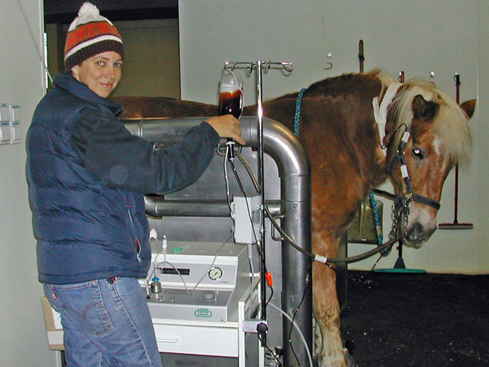

In many cases Kempchen was able to attain an improvement of the physical condition after just a few treatment sessions. In a study on equine laminitis with twelve animals, the overall health situation of all of the horses improved substantially', says Kempchen.

**- Today about 60 per cent of the treated animals only suffer from minor ailments or are even free of complaints.**

***- Before they became candidates for participating in this study, veterinary euthanasia would have been the only alternative.***

But the vast opportunities of hyerbaric therapy are not restricted to horses. The animal hospital in Wahlstedt, Germany has been very successful in treating dogs with ozone as well.

***- Open fractures are often accompanied by wound healing disorders.***

In many of these cases, hyperbaric ozone therapy has been an efficient supportive measure to ***alleviate suffering*** and ***accelerate the healing process***.

***- Basically ozone can be used in a large number of cases since it fights bacteria, viruses, and fungi reliably.'***

[http://www.openpr.com](http://www.openpr.com/news/89391/Making-use-of-natural-supportive-measures-for-traditional-treatment-in-veterinary-medicine.html)

**African Horse Sickness (AHS)**

**Bacterial Infections**

**Chlamydial Abortion**

**Chlamydial Diseases**

**Chlamydia Psittaci**

**E. Risticii**

**Eastern Equine Encephalomyelitis (EEE)**

**Ehrlichia Equi**

**Equine Ehrlichiosisi**

**Equine Encephalomyelitis (EE)**

**Equine Herpesvirus I (EHV-1) Infection**

**Equine Influenza**

**Equine Viral Arteritis**

**Equine Viral Rhinopneumonitis**

**Fungal Diseases**

**Leukemias**

**Lymphomas**

**Malignancies**

**Myeloencephalopathy**

**Respiratory Diseases of Horses**

**Rickettsial Agents**

**Togaviral Equine Encephalomyelitisl (EE)**

**Venezuelan Equine Encephalomyelitis (VEE)**

**Viral Rickettsial (VRCDs)**

**VRCDs of Horses, Cattle, Livestock, Domestic Animals.**

**West Western Equine Encephalomyelitis (WEE)**

**Oxygen Medicine**

**vs**

**Viruses**

**&**

**“Retroviruses”**

In a brief to the ***NATO Blood Committee***, the Surgeon General of the Canadian Armed Forces announced that… ”a 3-minute **OZONATION (O3)** of serum spiked with one million **HIV-1** particles per milliliter would achieve virtually **100% viral inactivation**.”

**Ozonized (O3)** biologic fluids, in which there is a presumed abundance of superoxide, **Singlet Oxygen (1O2)**, hydroxyl and peroxyl radicals and other highly reactive species, had both extracellular and intracellular virucidal properties.

The study also found that the **(O3/O2)** procedure would destroy several other lipid-encapsulated viruses, including **Simian Immunodeficiency Virus (SIV)** and various **other viral strains** of interest to ***VETERINARIANS***:

**- Bacteria *-****Aeromonas Hydrophila - Coliform Bacteria - Staphylococcus aureus*

**- Coxsackievirus**

**- Echovirus**

**- Fungi***- Candida Utilis*

**- Hepatitis Viruses**

**- Herpes Viridae *-****Simplex, Varicella-Zoster, Cytomegalovirus, Epstein-Barr Virus.*

**- Lipid-Encapsilated Viruses**

**- Orthomyxoviridae***- Influenza*

**- Paramyxoviridae *-****Mumps, Measles***- Retroviridae***- Human Immunodeficiency Virus (HIV), Simian Immunodeficiency Virus (SIV), Anemia Virus, Equine Infectious Virus*

**- Rhabdoviridae***- Rabies*

**- Polioviridae**

**Two teams of US virologists have used comparable (O3/O2) gas-diffusion techniques to confirm the Canadian findings.**

***In Germany:*** **10,000+ units** of human blood containing **hepatitis virus** were rendered safe through treatment with a mixture of **Ozone (O3)** and **Oxygen (O2)** for transfusion.

- http://www.ncbi.nlm.nih.gov/pmc/articles/PMC1490857/

***In Germany:*** A review of **300,000 patients** who had been given more than **5 million Ozone (O3)** treatments concluded that when strict protocols were followed the rate of adverse effects was **0.000007%** and that there was **no evidence of carcinogenicity**."

- Jacobs MTH: Untersuchung uber Zwischenfalle und Typische Komplikationenin der Ozone - Sauerstoff Therapie (AufzugAPRIL 1, 1993 CAN MED ASSOC J 1993; 148 (7) 1159 auf der Dissertation). Ozo Nachrichten 1986; 1: 5

***In Italy:*** 27 **herpes** patients with intravenous injections of **(O2) Oxygen** and **(O3) Ozone**... all patients healed completely after a minimum of one and a maximum of five injections. Five years later 24 of the 27 were still outbreak free. Re-infection was suspected in the other three.

- Dr. R. Mattassi, Division of Vascular Surgery, Santa Corona Hospital, Milan, Italy

**In Cuba:** Fifteen adults patients suffering from **herpes zoster** were treated with injections of **O3 Ozone / O2 Oxygen** for a period of fifteen days. All patients were completely symptom free after the treatment AND follow-up examinations a year later showed not one relapse."

- Center of Medical and Surgical Research, Havana, Cuba

**In United States and Canada:** It is well documented that **hypoxia (lack of oxygen)** occurs with **HIV** and **herpes infections**, which attack the circulatory and nervous system. Changes in tissue coloration (especially the hands and feet), often aggravated by temperature changes, occur in **HIV-positive** person.

**Hyperbaric Oxygen Therapy (HBOT)** reverses these symptoms and increase circulatory perfusion.

- Rapid Recovery Hyperbarics - www.HBOT4U.com

**Oxygen Medicine**

**Eliminating / Reducing / Minimizing**

**The Effects of Common Ailments**

**And Infectious Outbreaks in**

**Veterinary Practices**

**Staff / Visitors / Pets / Shelter Animals**

**(O3) Ozone Oxygen**

**Indispensable Healing**

**U.S. Public Schools - St Louis**

**5 Year Case Studies**

During the **influenza epidemic in St. Louis**, the most critical and advanced cases were transferred to an open air school, which made for high percentage of mortality.

However, in one particular ward, experiments were made with **(O3) Ozonized air** on cases approaching or at ***crises period of the diseases*** where patients were ***unable to inhale at all***,

… ***they were at once relieved and successfully carried over the crisis.***

Two schools were then used for an experiment, one with **(O3) Ozonized air** and another with ordinary air. Both schools contained approximately the same number of rooms.

**The following cases of sickness were observed and tabulated:**

|  |  |  |
| --- | --- | --- |
| **DISEASE / CONDITION** | **OZONIZED AIR** | **ORDINARY AIR** |
| **Tonsilitis** | **13** | **57** |
| **Sore Throat** | **24** | **60** |
| **Colds** | **46** | **64** |
| **Headache** | **9** | **66** |
| **Stomachache** | **0** | **25** |
| **Earache** | **1** | **15** |
| **Toothache** | **0** | **15** |
| **Indigestion** | **0** | **9** |
| **Fever** | **1** | **49** |
| **The Grippe** | **0** | **6** |
| **Pneumonia** | **0** | **4** |

**Comparing the total days that children were absent from each school, we find that:**

* In the school where **(O3) Ozonized air** was used, the school children were **absent a total of 475 school days**, due to the foregoing cases of sickness.

* In the school where **ordinary air** was circulated by means of the ordinary air ventilating system, the school children were **absent a total of 1,098 school days**, due to the foregoing cases of sickness.

**\* *Thousands of lives would be saved every* year** if homes and schools were equipped with apparatus for the circulation of **(O3) Ozone**.

**\*** Injected with the air of the building to the extent of one part of **(O3) Ozone** to one million parts of air, it effects***approximately 100% purification****.*

**\* In five years** that **(O3) Ozone** has been used in Public Schools of St. Louis, ***tuberculosis (TB) cases have been reduced 50%.***

**\*** Also, other diseases have been materially reduced.

|  |
| --- |
| **In "Report to National Warm Air, Heating and Ventilating Association"**  <http://mosao2.org/Article%20-%20O3/O3_schools_US_St_Louis.htm>  <http://www.understandingozone.com/article_drReviews.asp> |